I recently decided to join the 21st century and get a smartphone. And guess what, you can write programs on these things. I just happen to be a programmer, so it’s app writing time!!! Fish gotta’ swim; birds gotta’ fly.
This is just a proof-of-concept app. It doesn’t do anything useful, but I wanted to prove that it could be done. The app is a port of the VaultList sample in the SDK. It lists out all the files in the Vault. That’s all it does.
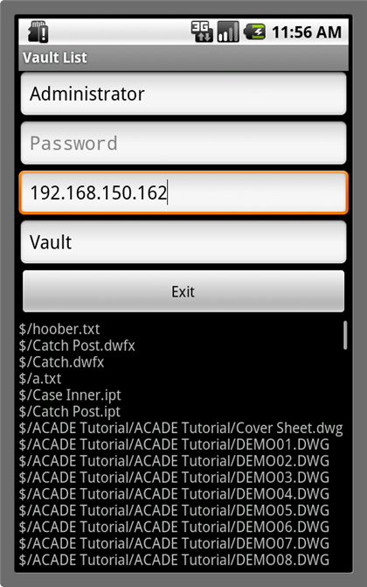
Requirements:
- Vault 2013
- An Android device - v2.1 or later
Click here for the app
Click here for the source code

Installation and Usage:
To get the app installed, you need to go into your phone settings an allow apps from unknown sources (non-Market locations). Next you need to get the .apk file installed somehow. The only way I found was to email it to my gmail account. When I use the Gmail client on my phone, it allows me to install the app.
Running the app is pretty straightforward. There are fields for the Vault information. Fill it in and hit run. You need a Wi-Fi connection to the network where Vault is running. If you are having trouble connecting, try using the IP address of the Vault server. You can also try opening your phone’s browser and going to http://[server]/AutodeskDM/Services/v17/DocumentService.asmx to verify that your phone can locate the Vault server.

Source Code:
The code is written in Java using the Eclipse IDE. It’s similar to my other Java sample app. For the Android app, I used a library called ksoap2 to make the web service calls to Vault. My code is written bottom-up. I only implemented the Vault API functions and classes that I needed. I didn’t implement the entire DocumentService or File class, for example. However the pattern for implementing these functions and classes is pretty obvious.
Special thanks to the DZone blog article for instructions on using ksoap2. These developer blogs are quite helpful!

Future plans:
I would like to write a useful mobile app for Vault one day. So if you have any ideas on what that app should be, post a comment.
I have no plans to develop in iPad or iPhone since it requires me to spend thousands of dollars buying a Mac.
As with all the samples on this site, the legal disclaimer applies.

